**PRAKTIKUM SISTEM DATABASE II**

**(TUGAS 1)**



**Disusun Oleh:**

Prames Ray Lapian - 140810210059

**PROGRAM STUDI S-1 TEKNIK INFORMATIKA**

**FAKULTAS MATEMATIKA DAN ILMU PENGETAHUAN ALAM**

**UNIVERSITAS PADJADJARAN**

**JATINANGOR**

**2022**

Soal:

1. SELECT * FROM OEHR_EMPLOYEES WHERE JOB_ID = 'IT_PROG';

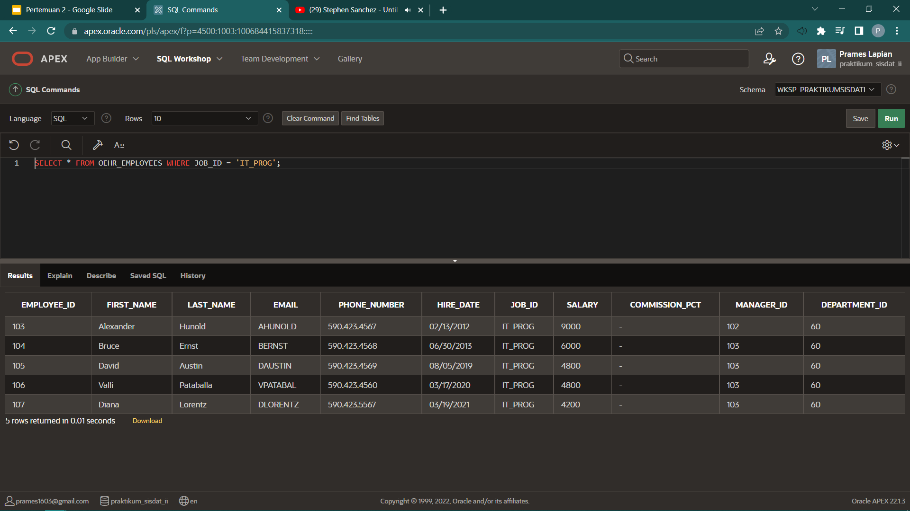

1. SELECT CUST_FIRST_NAME, CITY FROM OEHR_CUSTOMERS WHERE CITY = 'New Delhi';

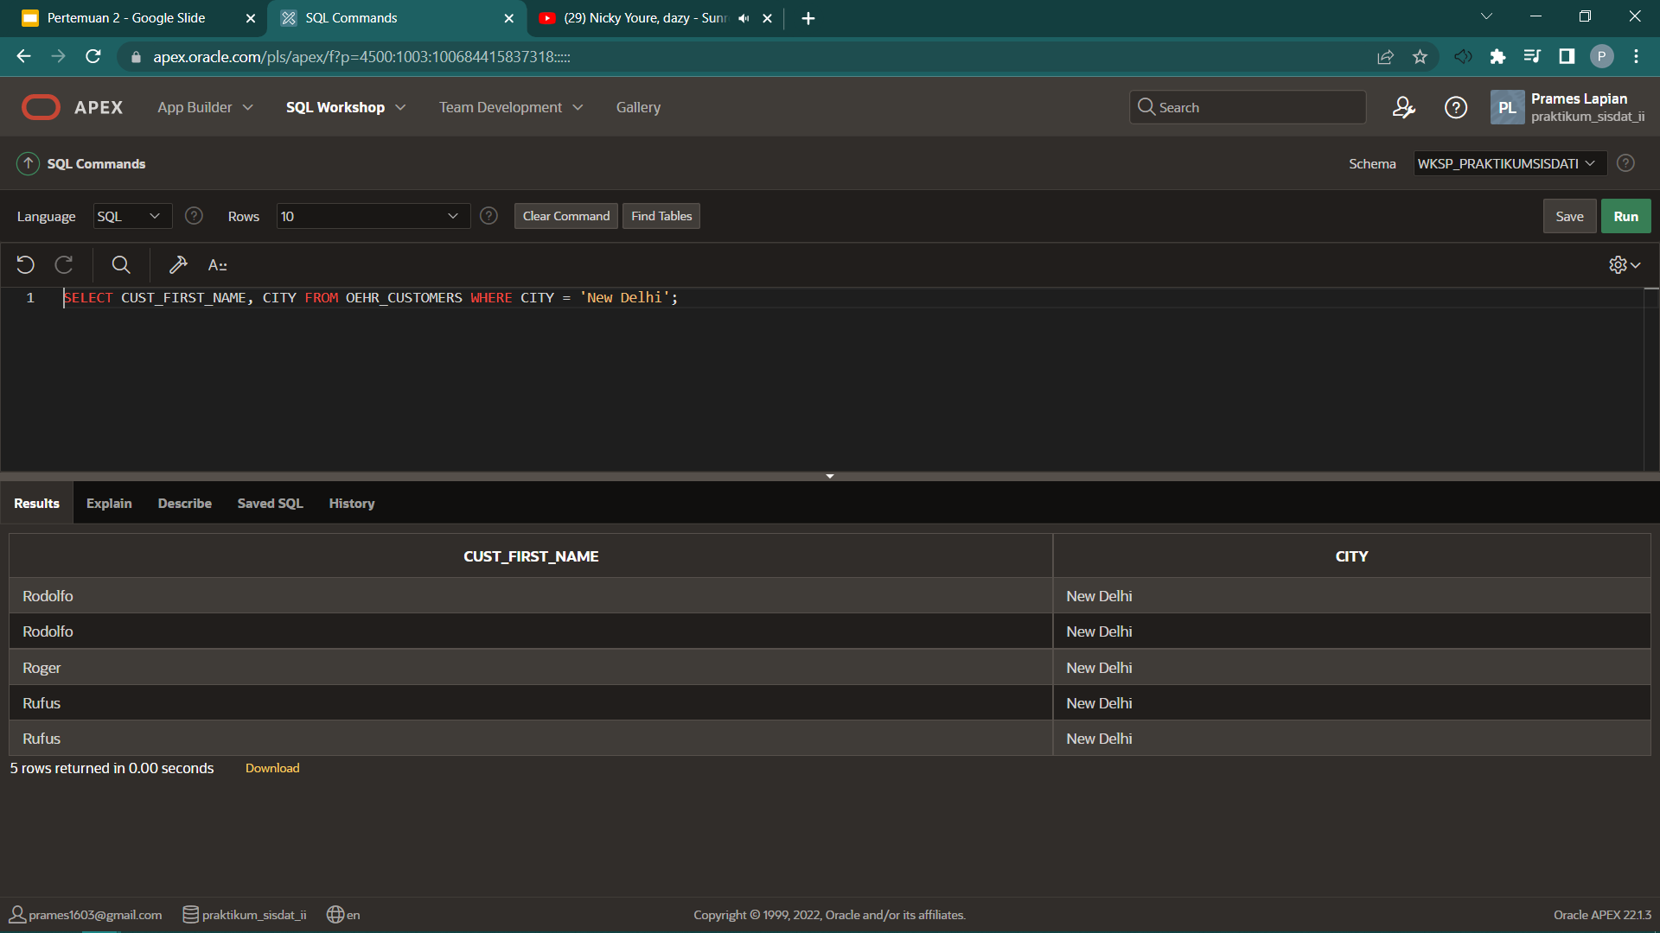

1. SELECT * FROM OEHR_EMPLOYEES WHERE JOB_ID = 'IT_PROG' AND SALARY > '4800';

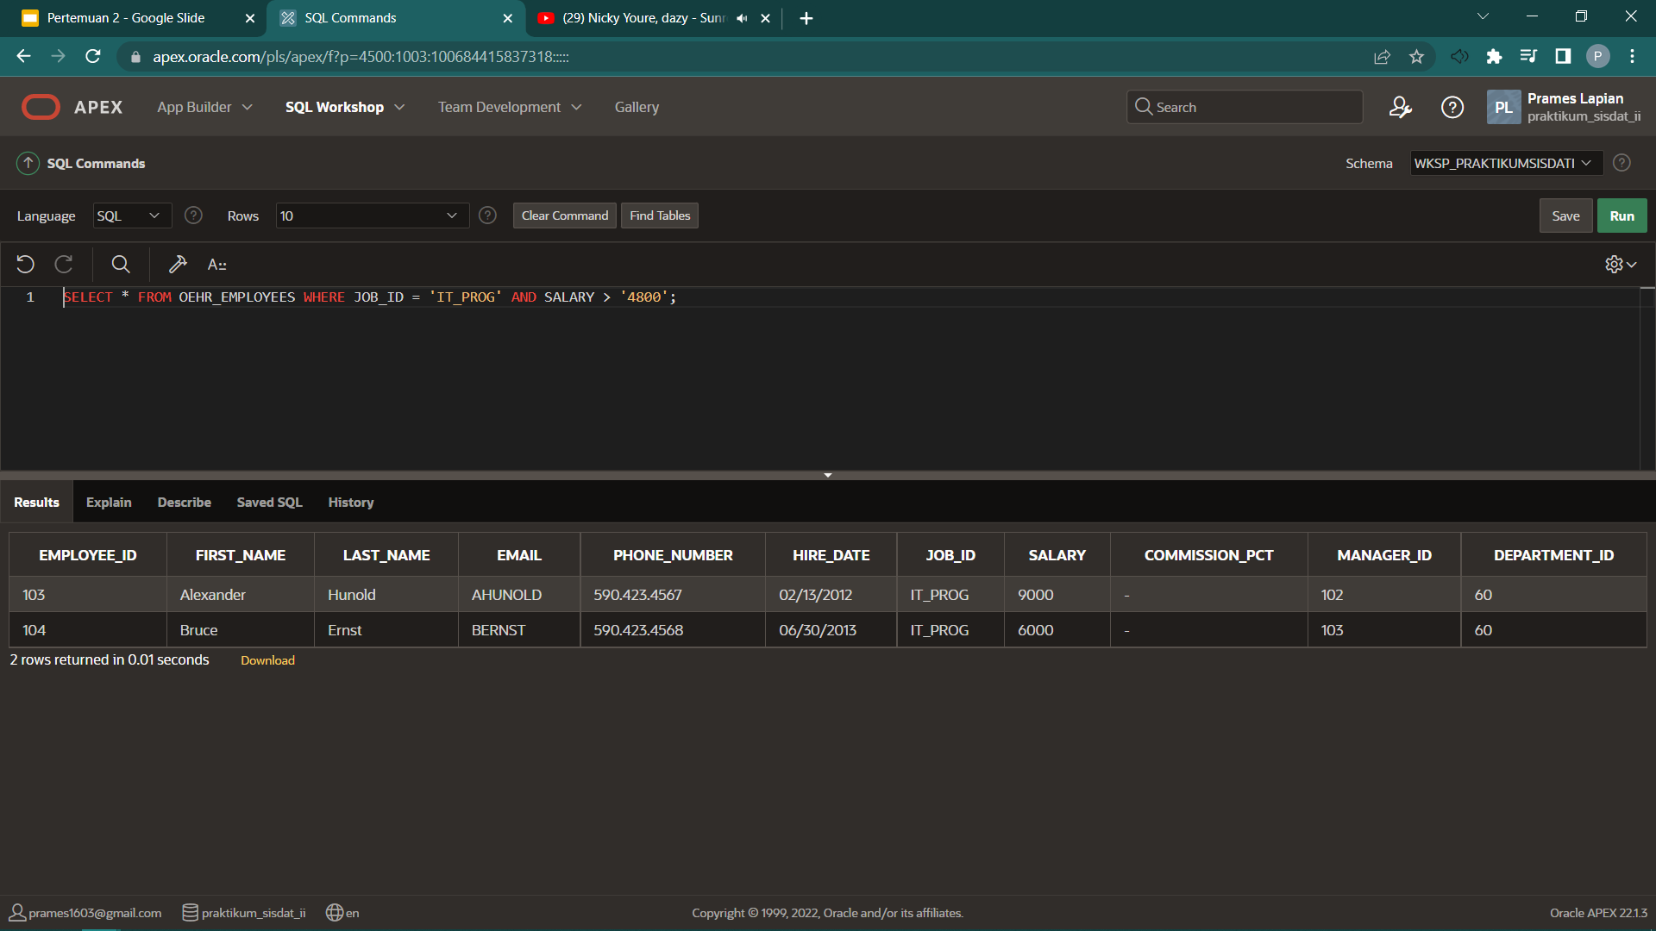

1. SELECT LAST_NAME, SALARY, SALARY + 500 FROM OEHR_EMPLOYEES;

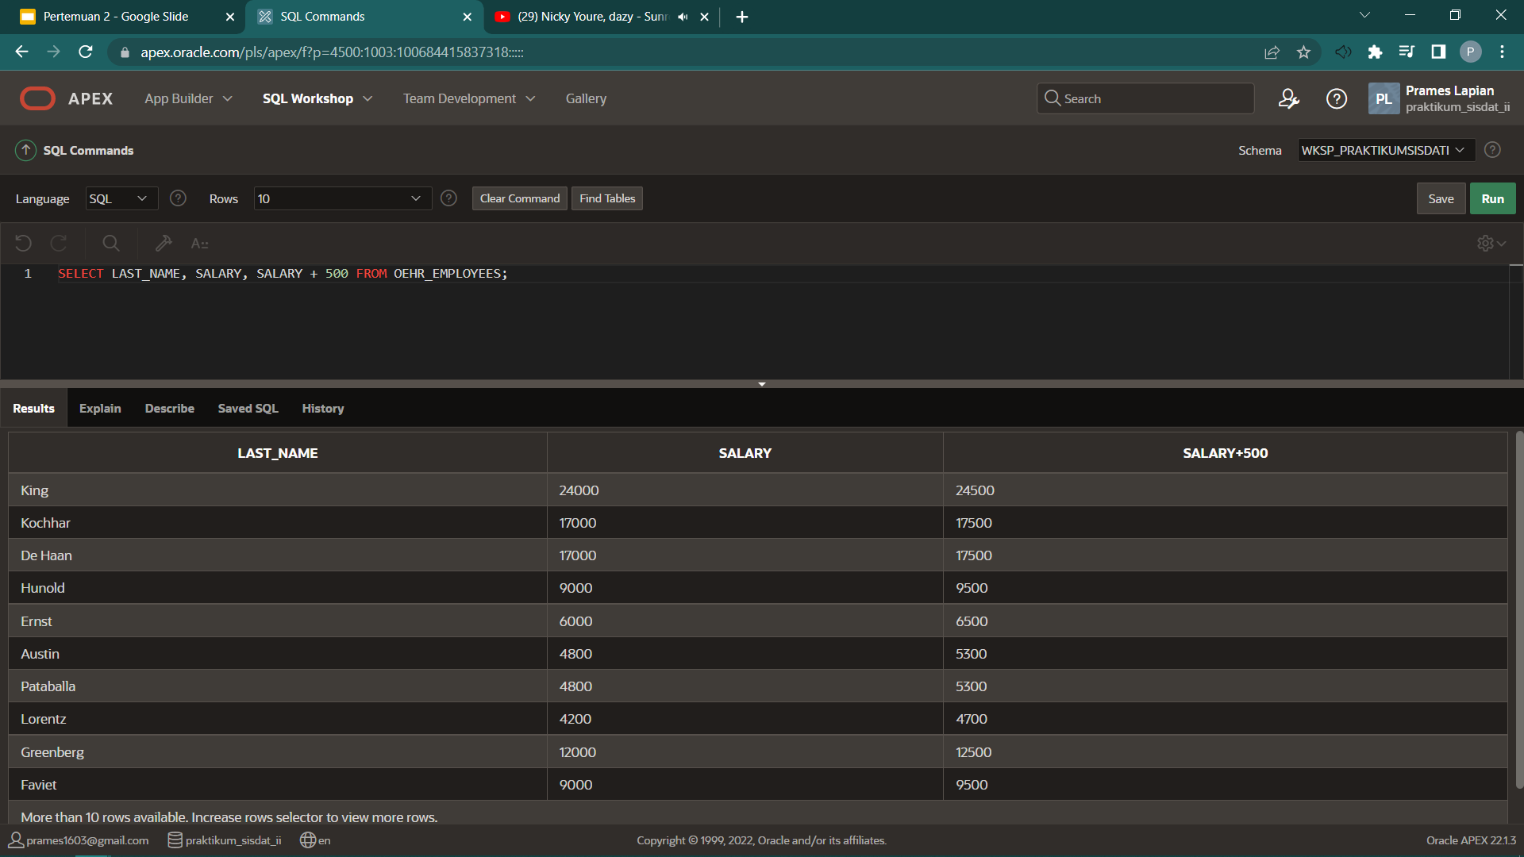

1. SELECT * FROM OEHR_EMPLOYEES WHERE JOB_ID = 'IT_PROG' AND ROWNUM <= 3 ORDER BY SALARY DESC;

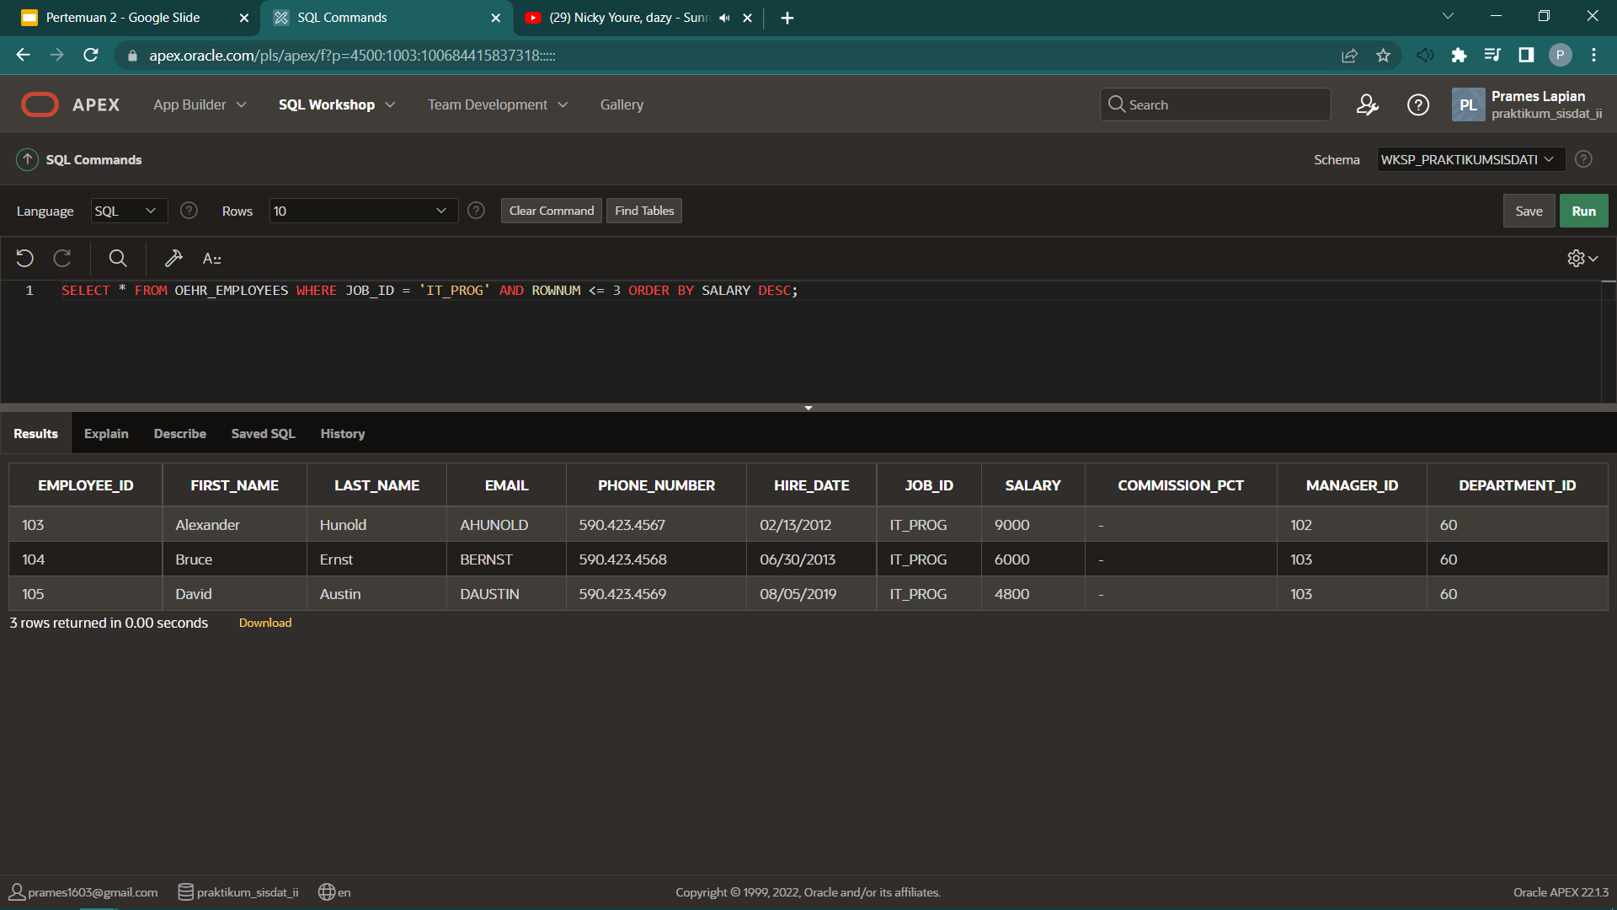

1. SELECT CONCAT(CONCAT(FIRST_NAME, ' '), LAST_NAME) AS "NAMA LENGKAP", SALARY AS "GAJI PERTAHUN", JOB_ID AS PEKERJAAN FROM OEHR_EMPLOYEES;

